HPC starter checklist
In general, you can find advice and instructions for HPC use on the Imperial HPC pages:
https://wiki.imperial.ac.uk/display/HPC/Getting+started

To get started using the cluster, you will need 4 things:

- Access to the HPC system
You should have received an email from noreply@imperial.ac.uk with the subject heading “Welcome from the Research Computing Service”. If you have not received this email, please let me know as soon as possible so we can try and get you added this week.

- A method of working on the cluster
The cluster is accessed using Secure Shell (SSH). If you are using Linux or macOS then you should have OpenSSH already installed alongside your operating system, which can be accessed from a terminal session such as command prompt. You can double check that this is available to you by logging into the HPC service for the first time. In a terminal session, enter the following, substituting your own username (in the form abc123), and entering your Imperial password when prompted:
ssh username@login.hpc.imperial.ac.uk
If this has been successful, you will see a message containing the title “Imperial College London Research Computing Service”.

If you are using Windows, there is no pre-installed SSH client. The recommended client is PuTTY, installed directly from: https://www.chiark.greenend.org.uk/~sgtatham/putty/latest.html
Once you have installed PuTTY, you can check that everything works by connecting to the HPC service for the first time. Open PuTTY, and fill in the fields as shown below:
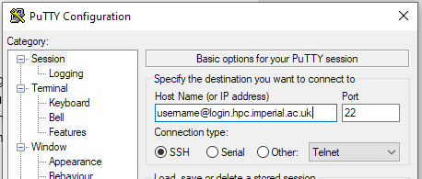
When prompted, you will then need to enter your Imperial password. If successful, you will see a message containing the title “Imperial College London Research Computing Service”.

If you want to use Imperial HPC but you are not currently connected to an Imperial network (for example, you are on a personal WiFi network or using eduroam), you will need to first connect to the Imperial VPN before attempting to connect to the cluster: https://www.imperial.ac.uk/admin-services/ict/self-service/connect-communicate/remote-access/virtual-private-network-vpn/

- Necessary modules are set up in your remote area
It will be useful to ensure that Python and R are set up on your area of the HPC system at this stage. You will only need to do this once. To install Python and R, you will need to first log in to the HPC service (as covered in the above section), and then enter the following two lines into the command line within your area of the remote system:
module load anaconda3/personal ​
anaconda-setup
This could take some time and may require you to respond “yes” when prompted. Once anaconda is fully installed, install R by entering:
conda install R
Once again, this could take some time and may require you to respond “yes” when prompted. Once both of these are installed, you should be able to enter python3 and code in Python on the cluster node. However, in general you should only run code in either R or Python by submitting them within jobs (as covered in the lectures and in the instructions document). (You will notice that if you attempt to launch R from your HPC node you will be given a stern message!)

- A method of file transfer
Files are exchanged between your local machine and your area on the HPC system using Secure File Transfer Protocol (SFTP). If you are working in Linux or macOS, you should be able to achieve this directly from the terminal. To check this, enter the following and enter your password when prompted:
sftp username@login.hpc.imperial.ac.uk
Once you are logged in, type and enter pwd to find out which area of the system you are in. By default you should land in username$HOME, and by entering put filename.R this file should be copied from your current local directory to your current remote directory. You can also similarly use the Secure Copy (SCP) method to transfer files – this, and further information about copying and getting files to/from the remote directory, will be covered in the main instruction document.
Note that SSH and SFTP are different methods to communicate with the HPC service – you can’t run SFTP from SSH or vice versa (you will need to quit out of one to use the other).
Windows users will have to download a separate programme to perform SFTP connections, and the recommended one is FileZilla. Linux and macOS may also find this more appealing than command line SFTP/SCP, because it provides a visual interface allowing you to drag and drop files and even edit files which are already copied to your area on the HPC system. Once you have downloaded FileZilla, ensure everything is working as it should be filling in the following fields and then clicking “Quickconnect” (use your own username and password, and the “host” field which is cut off in this screenshot is “sftp://login.hpc.imperial.ac.uk”):
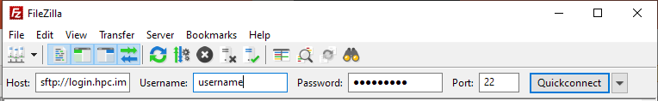
Once you have successfully established a connection, the terminal part of the application should read “Status: Directory listing of "/rds/general/user/username/home" successful” and you will be able to navigate around the file system of both your local machine and your area of the HPC system.

